**Purdue University nORTHWEST DEPARTMENTS OF ENGINEERING**

**ENGR15100: Software Tools for Engineers**

**Laboratory 3**

**PURPOSE:** Learn more about plotting routines.

For each problem, create a MATLAB script file and name it FIRSTNAME_LASTNAME_LAB3_ problemX.m. Put ALL the commands for the required steps in your script file:

* Be sure to clear the display and the memory.
* Display your name.
* Separate and label different steps using comments.
* For each plot question, you can use pause and close functions to stop and check the plots, and then close the figure window.

---------------------------------------------------------------------------------------------------------------------

%{

Class: ENGR15100: Software Tools for Engineers

Instructor: Xiaoli Yang

Author: [Student’s Name]

Assignment: Lab [No.]

File Name: LASTNAME_LAB[No.]_problem[No.].m

Date: [MM]/[DD]/[YY]

%}

%Delete an eventual pre-existing diary

delete xxx.txt

%Turn on a diary called mydiary.txt

diary xxx.txt

%clear screen

clc

%clear workspace

clear

disp('Your Name Here');

disp('');

disp('starting code: ');

%Completing lab x

%your source code here%

%Turn off the diary function

diary off

---------------------------------------------------------------------------------------------------------------------

**problem 1** (10 points)

* Create the following two data vectors:  
   area = .009 .021 .063 .402 .523 1.008 3.310 7.290 20.520  
   res = 2000 1012 364 110 46 20 8 3.5 1.2
* Make a linear plot with area on the x-axis and res on the y-axis. Call this Figure 1. Add labels of “CONDUCTOR AREA” for the x-axis, “WIRE RESISTANCE” for the y-axis, and a title of “Wire Resistance versus Conductor Area.”
* For Figure 2, repeat the above with a log-log plot.

**PROBLEM 2**(90 points)

1. (10 points) Plot the function $f(x)=\frac{x^{2}-3x+7}{\sqrt{2x+5}}$ for $-1≤x≤5$. Add appropriate plot title and label the axes.

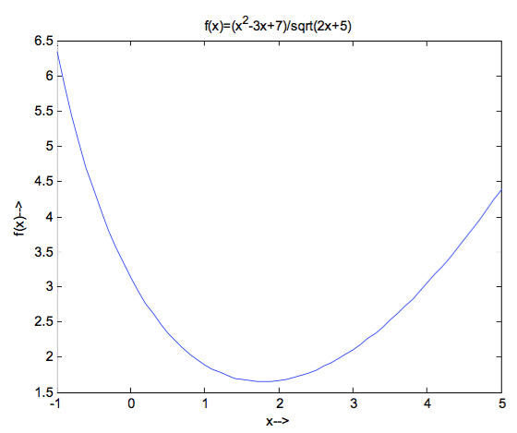After completing this step, you should obtain a plot in the Figure Window similar to the sample plot shown below:

1. (10 points) Plot the function $f(x)=(3cosx-sinx)e^{-0.2x}$ for $-4≤x≤9$. Add appropriate plot title and label the axes.

After completing this step, you should obtain a plot in the Figure Window similar to the sample plot shown below:

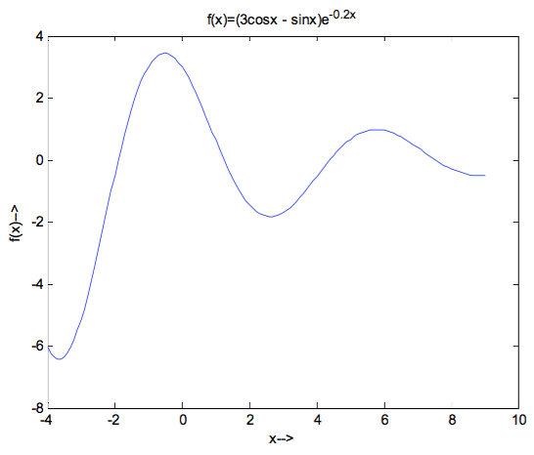

1. (10 points) Make two separate plots of the function $f\left(x\right)={3x}^{4}+10x^{2}-3,$ one plot for $-4≤x≤3$ and one for $-4≤x≤4$. Add appropriate plot title and label the axes.

After completing this step, you should obtain two plots in the two Figure Windows, respectively, similar to the sample plots shown below:

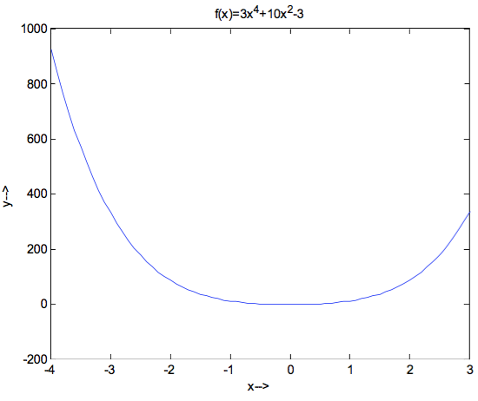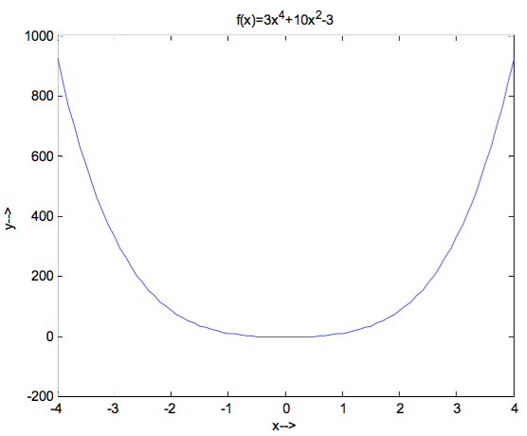

1. (10 points)Two parametric equations are given by:

$$x=\cos^{3}\left(t\right), y=\sin^{3}\left(t\right)$$

$$u=sin\left(t\right), v=cos\left(t\right)$$

In one figure, make plots of $y$ versus $x$ and $v$ versus $u$ for $0≤t≤2π$. Format the plot such that the both axes will range from -2 to 2. Add appropriate plot title and legend, and label the axes.

After completing this step, you should obtain two plots in a single Figure Window similar to the sample plots shown below:

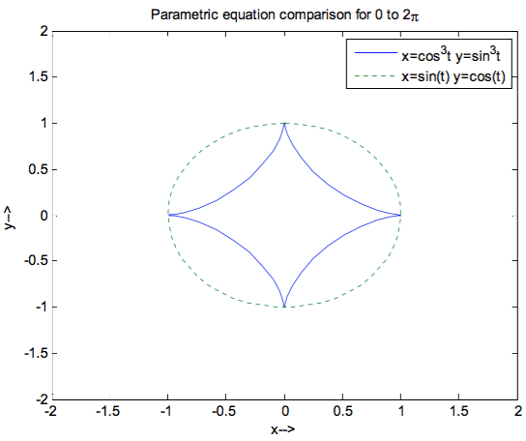

1. (10 points)The following data gives the approximate population of the world for selected years from 1850 until 2000.

|  |  |  |  |  |  |  |
| --- | --- | --- | --- | --- | --- | --- |
| Year | 1850 | 1910 | 1950 | 1980 | 2000 | 2010 |
| Population (billions) | 1.3 | 1.75 | 3 | 4.4 | 6 | 6.8 |

The population, $P$, since 1900 can be modeled by the logistic function:

$$P=\frac{11.55}{1+18.7e^{-0.0193t}}$$

where $P$ is in billions and $t$ is years since 1850. Make a plot of population versus years. The figure should show the information from the table above as data points and the population modeled by the equation as a solid line. Set the range of the horizontal axis from 1800 to 2200. Add a plot title and a legend, and label the axes

After completing this step, you should obtain two plots in a single Figure Window similar to the sample plots shown below:

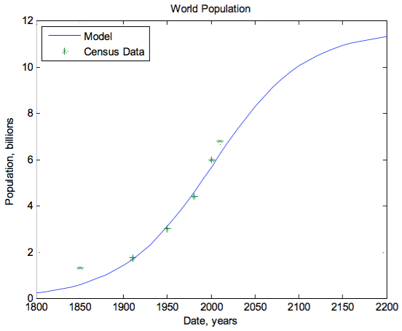

1. (20 points)The ideal gas law relates the pressure $P$, volume $V$, and temperature $T$ of an ideal gas:

$$PV=nRT$$

where $n$ is the number of moles and $R=8.3145 J/(K mol)$. Plots of pressure versus volume at constant temperature are called isotherms. Plot the isotherms for one mole of an ideal gas for volume ranging from $1$ to $10 m^{3}$, at temperatures of $T = 100, 200, 300, and 400 K$ (four curves in one plot). Label the axes and display a title and a legend. The units for pressure are Pa.

After completing this step, you should obtain four plots in a single Figure Window similar to the sample plots shown below:

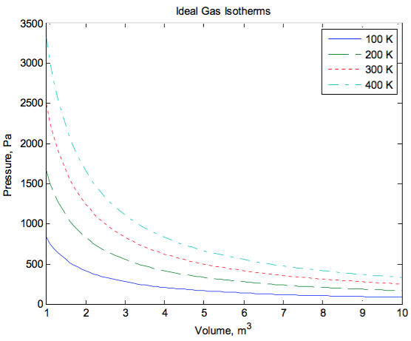

1. (20 points)Make a plot of a circle with its center at (4.2, 2.7) and radius of 7.5. Add appropriate plot title and label the axes. After completing this step, you should obtain a circle in a single Figure Window similar to the sample plots shown below:

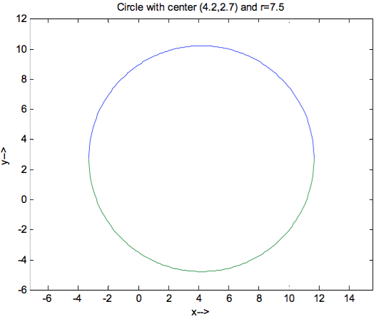

**SUBMITTING YOUR LAB:**

Submit your lab by uploading .m files using the Blackboard Assignment feature no later than the date specified.